Reflections: Why protect the coast at Labrador Park? (10 min)

*This activity is to be done after groups have completed Station A & B.*

The Lookout Deck is located near the mouth of a small stream and along the coast. What do you observe about the land found at the coast?

1. 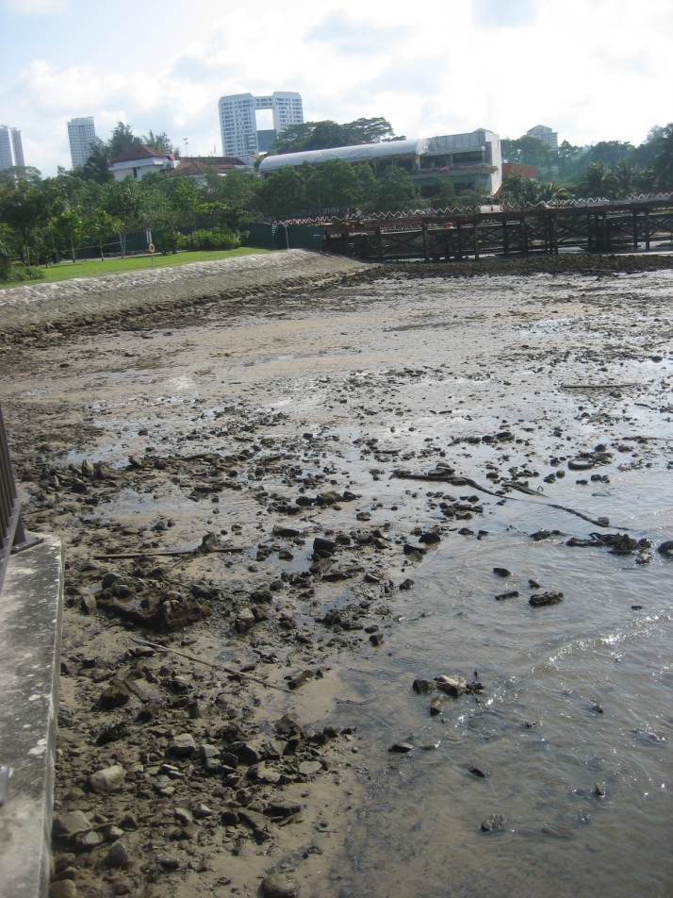Write down 5 differences that you will use to describe the coast that you see at the Lookout deck as compared to the photograph on the right?
2. What do you notice about the banks, water level and energy found at the coast at the Lookout Deck? Compare this to the coast observed near the Red Beacon? Provide at least two similarities and two differences:

*Photograph taken by Elissa Goh on 21st June   
2011, 9.05 a.m.*

1. Which coast (Station A or B) requires more protection? Provide reasons for your choice.

NParks is trying to preserve Singapore’s legacy.   
What are some historical landmarks that have been preserved?   
Why is there a need to preserve these landmarks/monuments?